**Practical No :** 4 Roll No :

**Subject :** Cloud Computing

**Title:** Design and develop custom Application (Mini Project) using Salesforce Cloud (Mini

Project)

**----------------------------------------------------------------------------------------------------------------**

**Login > App Launcher**

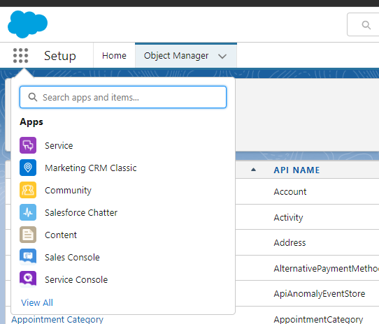

**New Lightning app :**

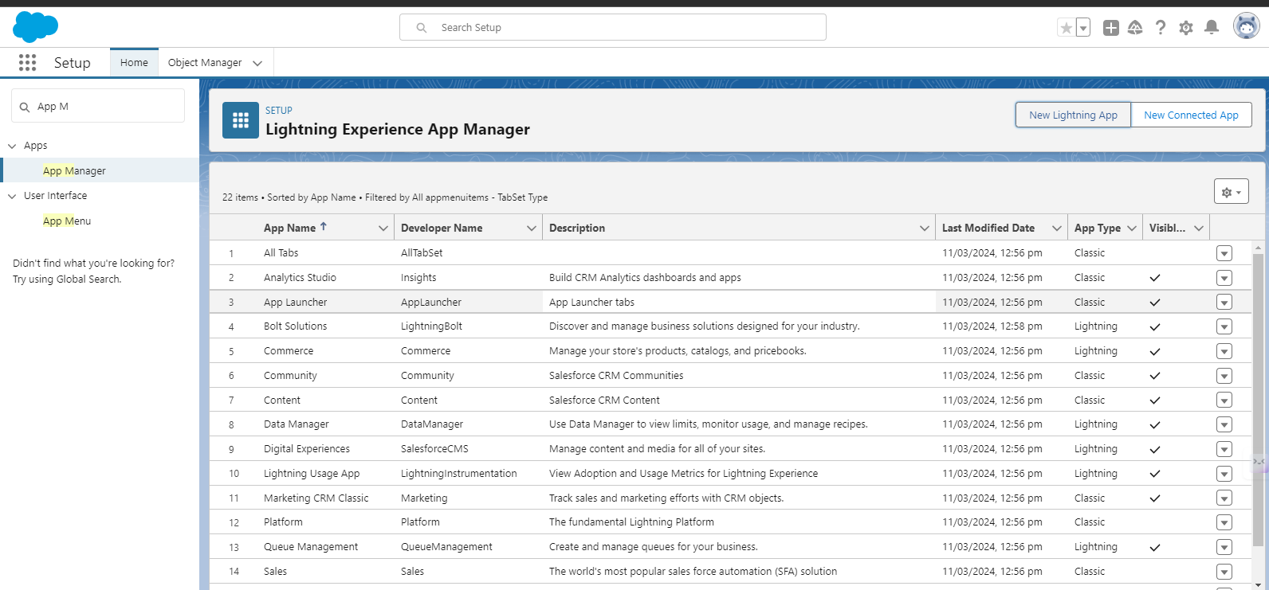

**Fill The form > Next :**

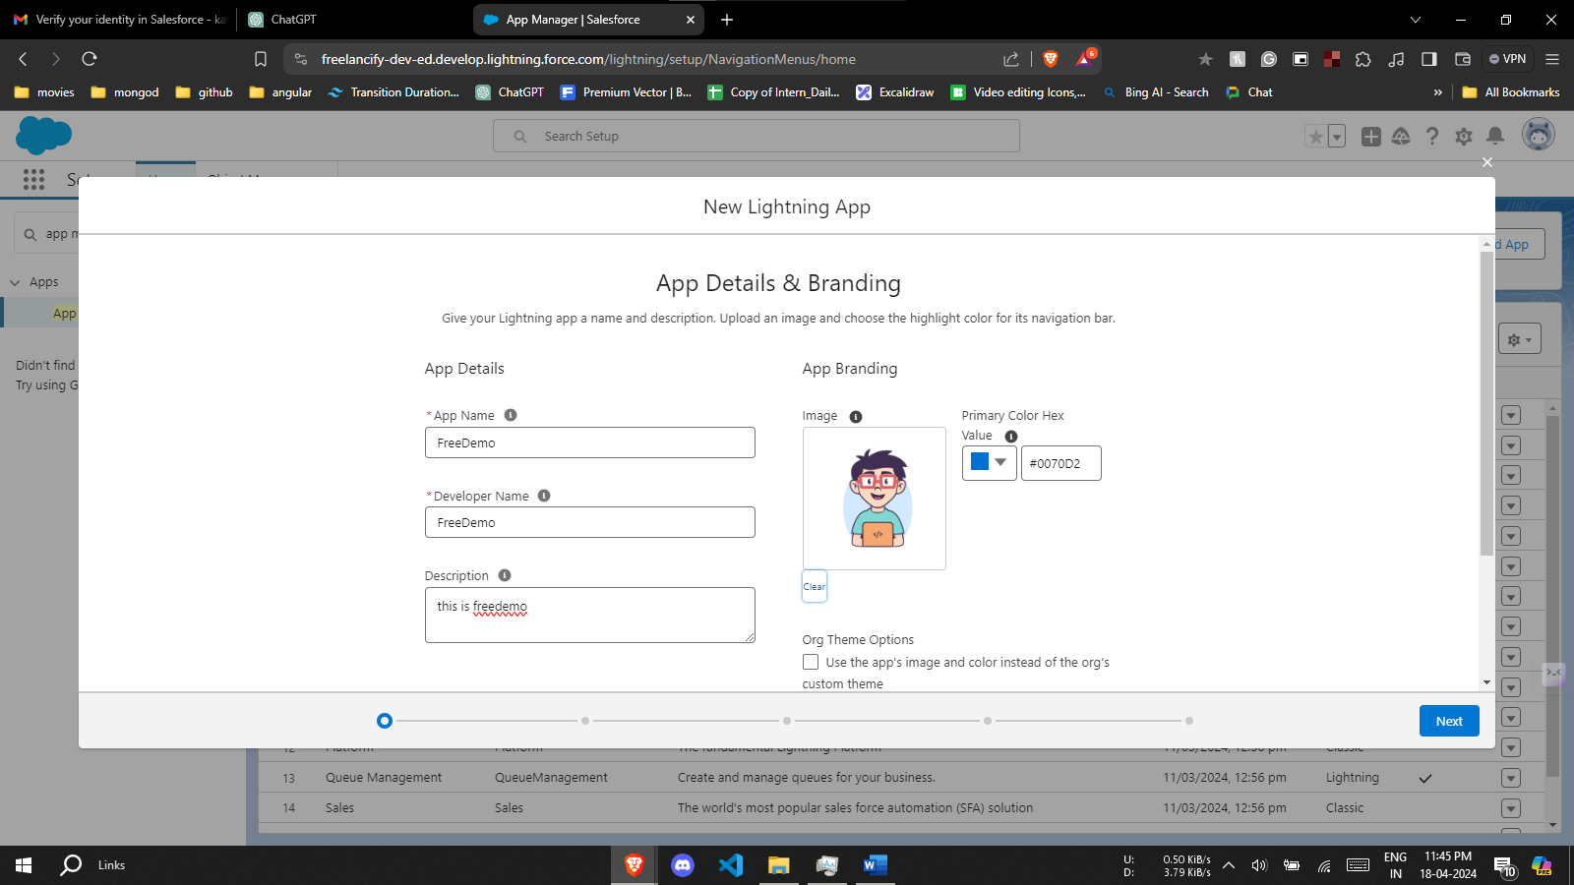

**App Option (optional )**

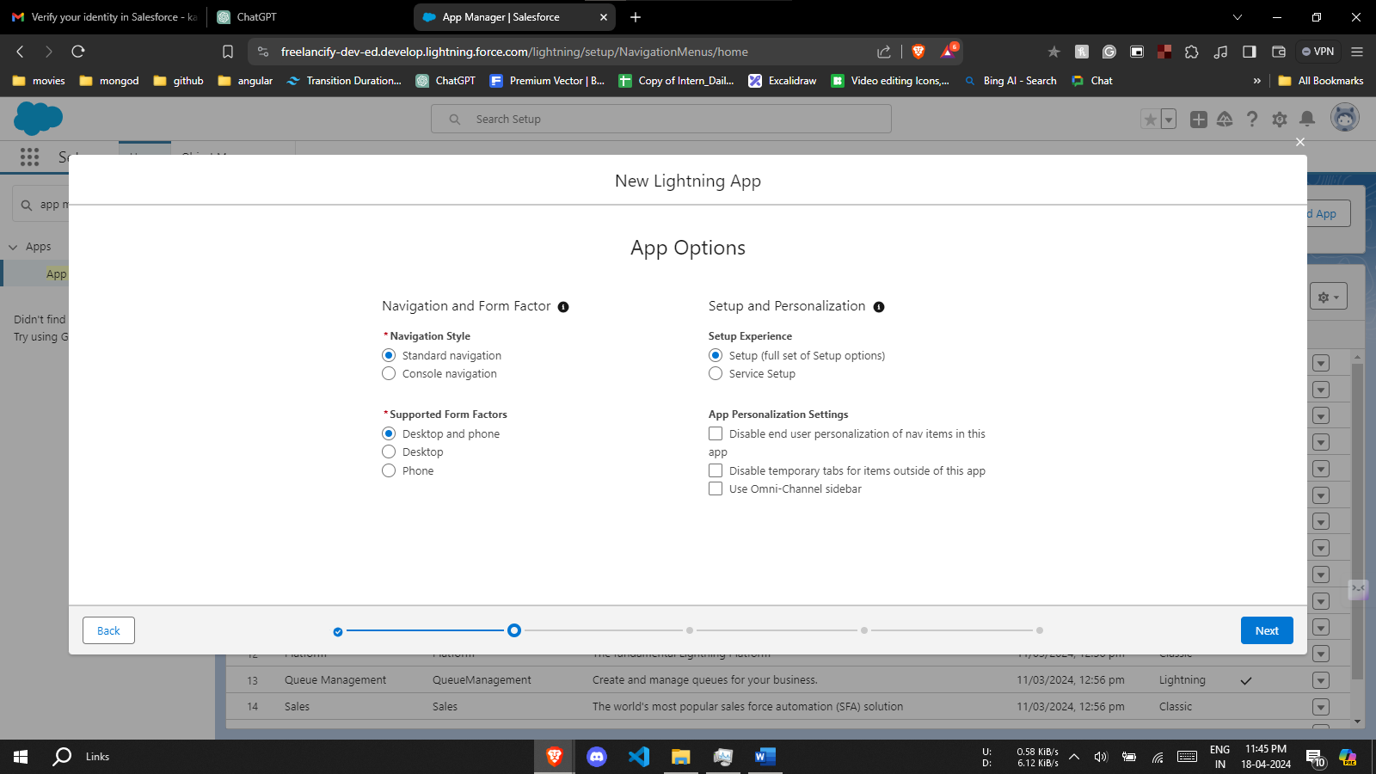

**Utility Items :**

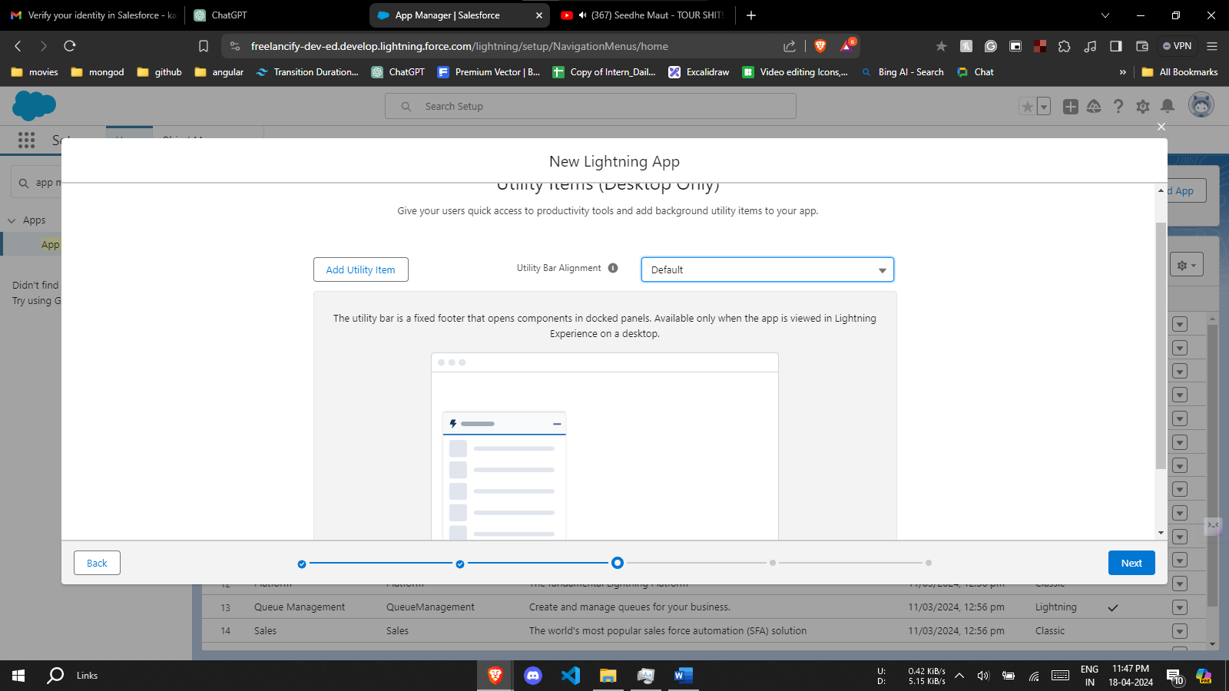

**Navigation :**

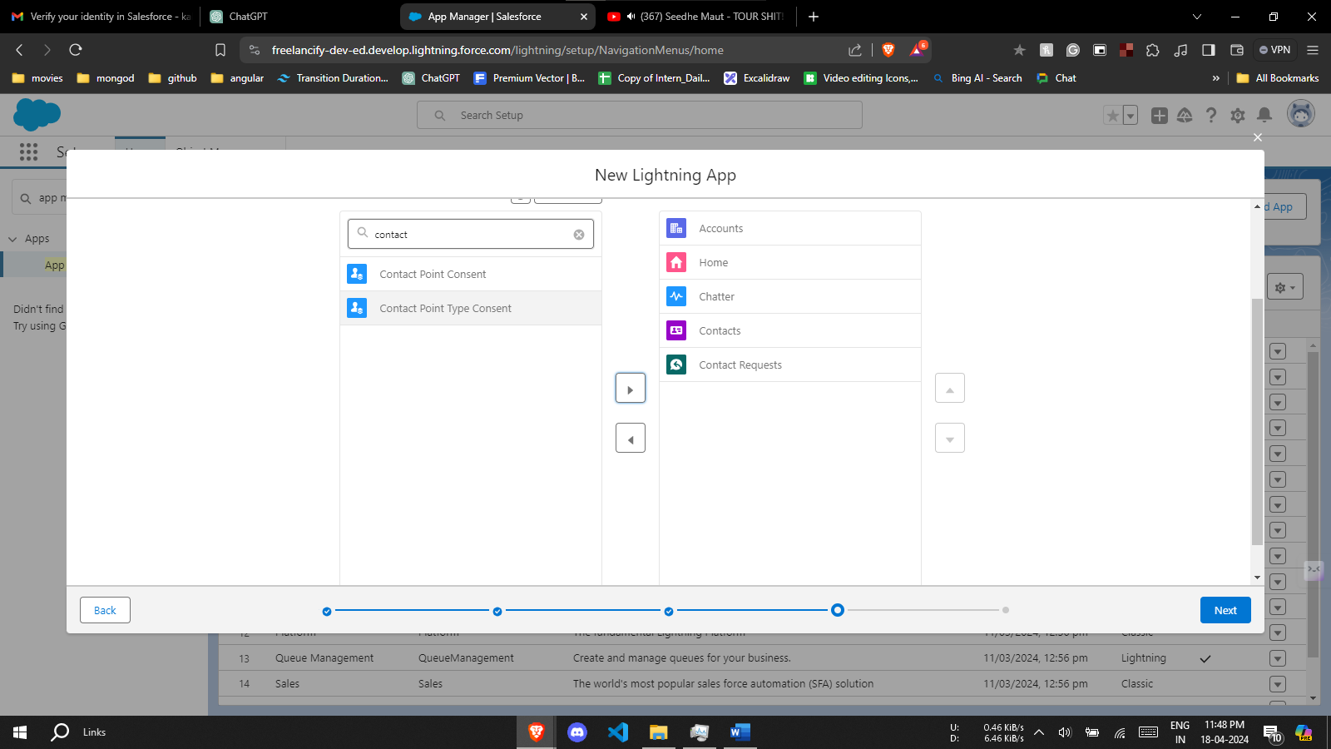

**User Profile :**

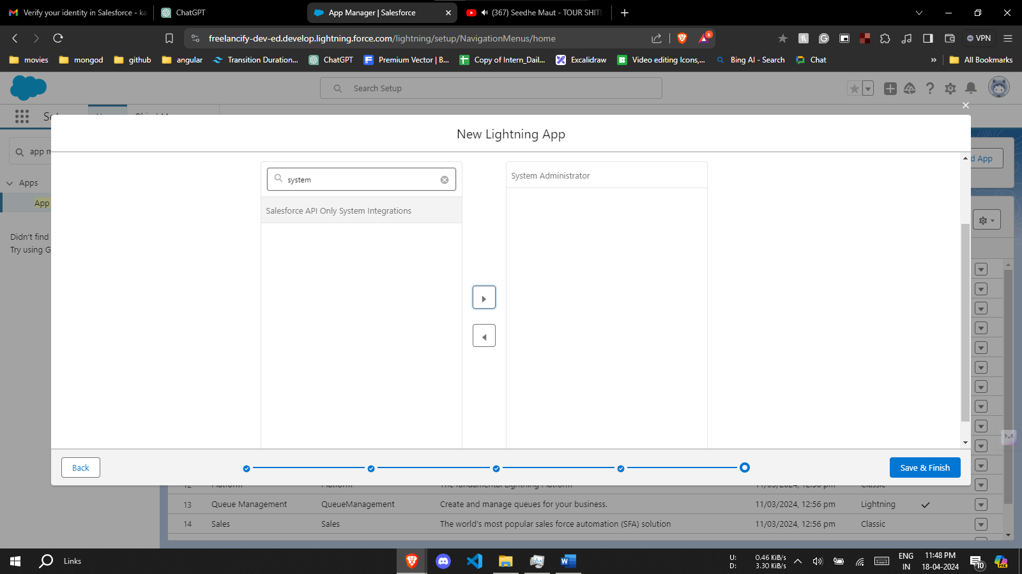

**App Launcher > search for app created :**

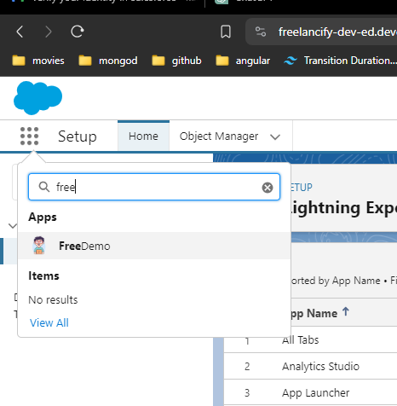

**Add New Contact**

